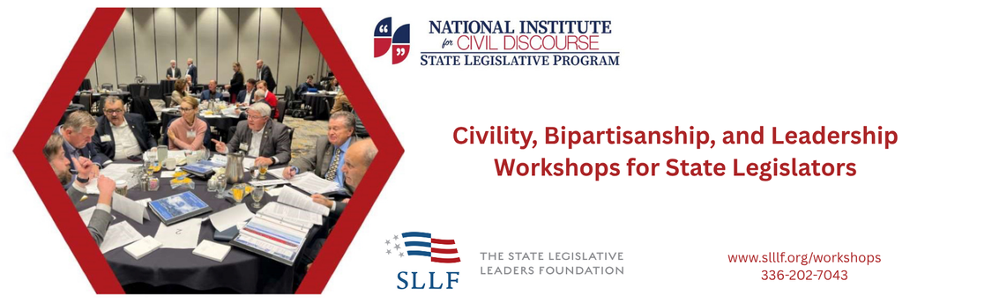

Beyond Party and Ideology: Building Working Relationships (4- 4 ½ hours)
Legislators begin with a meal to honor fellowship, learn about the foundation and critical role of civility to our nation’s Founders, and watch examples of unlikely friendships. Then, a bipartisan team of Next Generation Facilitators – current or former state legislators from nearby states - move the large group into breakout rooms for small group work. No more than 20 Democrats and Republicans from both chambers will share personal journeys, define the current state of civility, identify barriers and opportunities to leverage change, and create an action plan. During the last hour of the workshop, all legislators return together to report action plans and vote on priorities.

Legislative Success: Building Relationships and Coalitions (6 - 8 hours)
Despite what candidates promise in their campaigns, they cannot solve any of their state’s problems alone. To be successful, they must convince a majority of colleagues in their chamber, a majority of legislators in the other chamber, and the governor that their proposal deserves to be a law. To do that, legislators must do two things: build relationships with their colleagues and put together coalitions to get their bills passed. In this session, we examine the importance of civility and relationships in historical and contemporary legislatures and participate in activities that encourage relationships and develop strategies for working together.

Tips for Being an Effective Legislator: Civility (1 – 1 ½ hour)
This session, led by former Idaho Senator and Senate President Pro Tempore Brent Hill leads participants in a discussion of the origins (both historical and etymological) of civility and why it is so important to create a successful legislative session. Speaking from many years of leading the Idaho Senate. Senator Hill offers practical examples of legislative civility and how civil relationships within and across parties makes it easier to dot the work of the people.

What Got You Here Won’t Get You There (3/4-1 ¼ hour)
This is a session specifically designed for newly elected legislators, great for new member orientations. The session is designed to help newly elected legislators transition from campaigning to governing. The reality is that many of the skills and approaches that contribute to winning modern campaigns (viewing the other party as the enemy, claiming to be able to solve policy problems alone and speaking on every issue) are the opposite of the abilities necessary to be an effective legislator. An effective legislator must be able to build relationships, work with members from both parties, respect the legislative institution, develop policy expertise and make cogent arguments.

Engaging Differences – What Civility Is and What it Ain’t (1 or 1 ½ hour session)
This session offers a discussion of the historical and contemporary significance of civility in America’s representative government. We will explore the founders’ fear of “the spirit of party” and the guardrails, many of which seem to be breaking down, the put in place to restrict it. Further, participants will join in some activities designed to help them build relationships across partisan and ideological lines and sharpen the skills necessary to be an effective legislator. Whether a freshman legislator or seasoned lawmaker, each participant will discover practical civil discourse best practices as they relate to leadership skills.

The Case for Civil Discourse: Founding Fathers (1 or 1 ½ hour session)
The nation’s capacity to work across our differences respectfully and with civility has reached record lows. Analyses of the more than 13 million roll call votes cast since 1789 reveal that the Congress is now the most polarized ever. The American Founders recognized that differences escalating into dysfunctional partisan animosity was the chief reason every previous republic had failed. Building a republic robust to partisan animosity was the chief problem the Founders aimed to solve in framing the U.S. Constitution. The main reason the American system takes separation of powers further than any other is to prevent parties from imposing their will on everyone else.

The Bay of Pigs and the Cuban Missile Crisis (1 or 1 ½ hour session)
This session explores how to realize the benefits of diverse perspectives within a legislature or a caucus without falling into dysfunctional conflict. Drawing on research in group decision making, National Institute for Civil Discourse Executive
Director Keith Allred leads this interactive, skills building session. The conversation starts with a discussion of the Kennedy Administration’s decision to sponsor an incursion into Castro’s Cuba and the monumental blunder that it turned out to be. Just 18 months later, the same group confronted a daunting challenge in the Cuban Missile Crisis. This time, when the stakes could hardly have been higher, Kennedy managed differences within his administration completely differently with vastly superior results.
Working Togeher: A Legislative Budget Building Exercise (1 ½- 2 ½ hours)
The only way to get a bill passed in the legislature or an ordinance passed through city council is to get a majority of your colleagues to support it. There are no dictators in American politics. While coalition building is essential for a functioning democracy, it seems to have become a lost art of late. In this session, we will help participants rediscover the art of finding common ground by examining and practicing strategies for finding that “sweet spot” in negotiations where everybody gets something and nobody gets nothing. Participants will take part in an activity where they have to find consensus as members of the House and Senate Budget Conference Committee on a variety of contentious issues.

What Does it Mean to Lead? A Look from Plato’s Cave (¾ - 1 hour)
Leadership is never easy, especially when those being led want to go a different direction than their leaders. Using Plato’s “Allegory of the Cave,” this session examines the responsibility of leaders when those they lead, perhaps out of fear or ignorance, don’t want to follow. Should the leader leave them where they are familiar but in darkness or lead them out into a better place even if they are reluctant? We will examine what it means to lead and the “darkness” that may restrict all of us in our “caves.”

Ethical Leadership: Knowing and Doing the Right Thing (1 -1 ½ hours)
It seems that almost daily, we are reading or hearing about a public official who has behaved in an unethical manner-someone takes a bribe, harasses an employee or misuses campaign funds. In this session, we will explore the difference between ethical and legal as well as the reasons that unethical behavior seems to be on the rise. Further, we will use real world scenarios (developed by public officials) to discuss what is and is not ethical behavior. This session will give participants the opportunity to think about what they should do in the calm of hour before they get caught up in the heat of the moment.

The Seven “Abilities” of Effective Leadership (½ - ¾ hours)
Have you ever wondered what makes a great leader—one that can motivate and inspire others to achieve extraordinary results? Reflecting on American Presidents from the last eighty years. In this session, we explore seven qualities associated with effective leadership, linking each one to a particular president. For example, one of the reasons that Ronald Reagan was an effective president was his credibility. People, friends, and foes alike trusted that Reagan meant what he said. Effective leaders are true to their word and make promises rather than threats. The other “abilities” are likeability, capability, adaptability, comfortability, compatibility and visi(ona)bility.

NATIONAL INSTITUTE FOR CIVIL DISCOURSE | nicd.arizona.edu/nextgen | 614-398-0773
STATE LEGISLATIVE LEADERSHIP FOUNDATION | sllf.org | 336-202-7043

